Martes 12 de mayo, 2020
1º ESO

Para dudas, puedes contactar conmigo en el siguiente e-mail: miguel.sanjose@sanviatorvalladolid.com

UNIDAD 3
Workbook Pag. 22

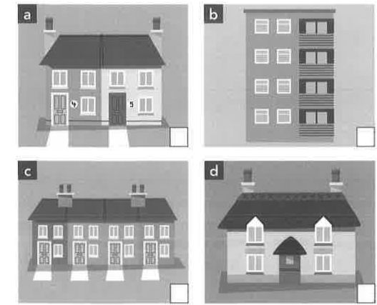
1 Complete the definitions with a type of house. Match four of them to the pictures.

2 cottage 3 bungalow 4 terraced house 5 flat 6 semi-detached house

a 6 b 5 c 4 d 1

2 Find these words in the wordsearch:

3 Complete the sentences with an appropriate adjective from the box.
busy • clean • crowded • dirty • empty historic • lively • noisy • quiet

1 clean 2 lively 3 crowded/busy 4 historic 5 quiet

PAGINA 22 Y 23
4 Label the picture of the house.
drive • garage » shed » front door • roof chimney • front garden ■ porch • path • gate

- ____________________
- ____________________
- ____________________
- ____________________
- ____________________
- ____________________
- ____________________
- ____________________
- ____________________
- ____________________

1 Look at the sentences from the text. Underline in red the verbs in the present perfect simple and underline in blue the verbs in the past simple.

Freiburg has been an eco-city for many years. The historic city centre has been car-free since 1973. It ail began in the 1970s, when local people were strongly against plans for a nuclear power station. Rolf Disch started with his house 20 years ago.
This remarkable eco-city has won many awards.

2 Complete the grammar rules with these words.

completed • continue • specific • started the past • the present

We use the present perfect simple to talk about an event in (a) __________________ without saying when it happenedd We use it to talk about recent events that have a result in
(b) __________________ We also use It to talk about actions or situations that (c) __________________ in the past but (d) __________________ In the present.
We use the past simple to describe (e) __________________ actions in the past. We also use it when we mention the (f) __________________ moment in the past when something happened.

