Thursday 4th June:
Hello children’s:
The activities to the Activity BooK, you must complete in the activity book.
The grammar you must copy in your note book, take a photo and send me.
And the activities that I send you to review, complete on the computer.
If you can’t hear the audios, tell me and I will send it to your email as an attachment, please.(Si no podéis escuchar los audios por favor decírmelo y os lo mando a vuestro correo como archivo adjunto).

Nº 1. Listen and read.
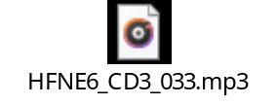
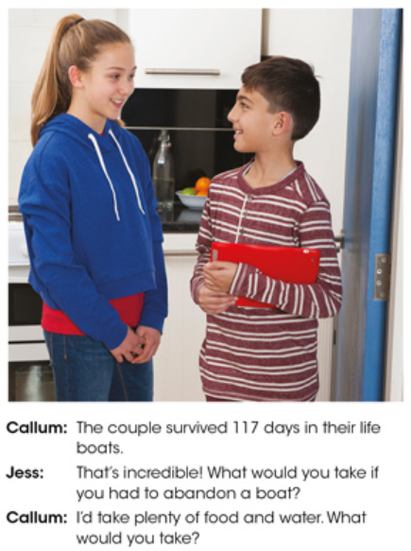
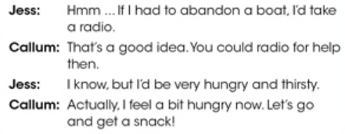
Nº 2. Look, copy grammar wall in your note book and learn. Take a photo and send me.
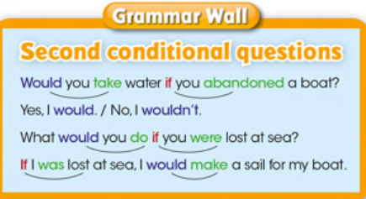

Nº 3. Read and choose.
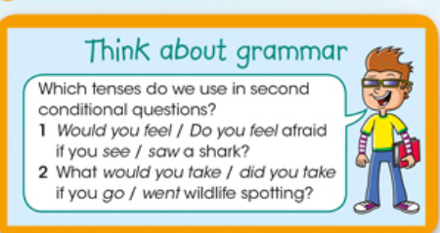
Answers:

Nº 4. Write sentences with the second conditional questions and second conditional, using this vocabulary. Look at the examples.
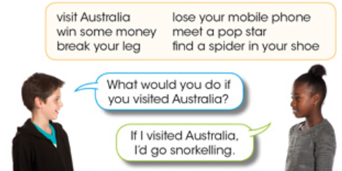

Answers:

Activity BooK:
Page 83: Nº1. Complete the questions.
Page 83: Nº2. Write the questions.
Page 83: Nº3. Listen and write the missing words.
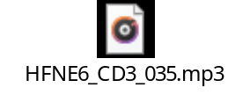
Page 83: Nº 4. Write the questions.

Nº 5.

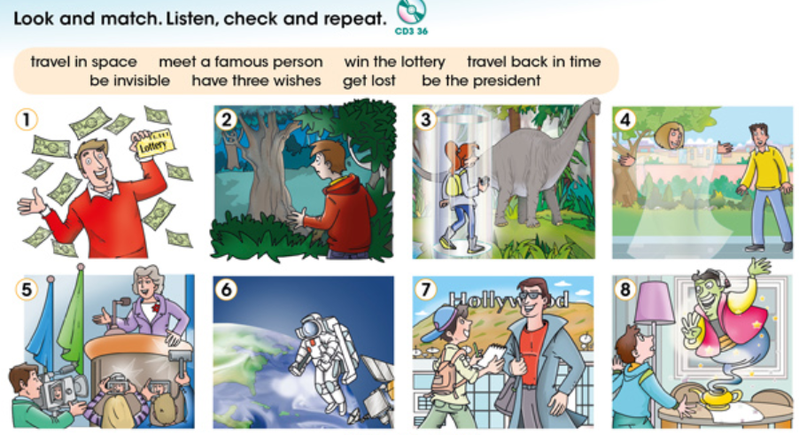

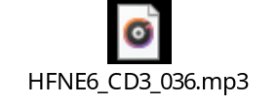

Nº 6. Copy the new vocabulary in your note book and translate in Spanish. If you don’t understand something, you will ask me. Take a photo and send me.

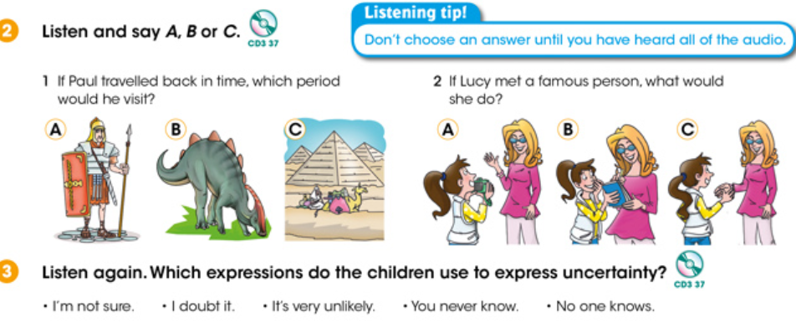
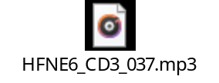
Answers:

Answers:

Activity BooK:
Page 84: Nº1. Write the missing letters.
Page 84: Nº2. Write A or B.
Page 84: Nº3. Read and learn.
Page 84: Nº4. Answers the questions in nº 3.

“Una vez hechas las tareas y los ejercicios y para dudas, puedes contactar conmigo en el siguiente e-mail”:
veronica.tauler@sanviatorvalladolid.com

