Thursday 07th May:
Hello children’s, How are you?:
The activities to the Activity BooK, you must complete in the book.
The grammar you must copy in your note book, take a photo and send me.
And the activities that I send you to review, complete on the computer.
If you can’t hear the audios, tell me and I will send it to your email as an attachment, please.(Si no podéis escuchar los audios por favor decírmelo y os lo mando a vuestro correo como archivo adjunto).

Nº 1. Listen and read.

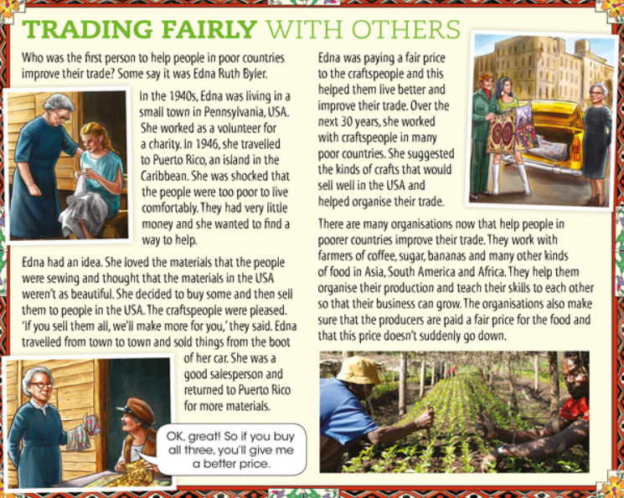

Nº 2. Answer this questions.
Edna and Ruth Byler showed a lot of initiative to help the people in Puerto Rico.
What’s initiative?
Answer:
Why is it important?
Answer:
Nº 3.
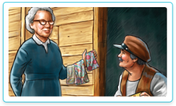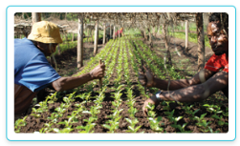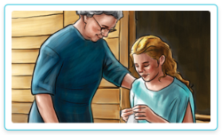
Activity BooK:
Page 72: Nº1. Read and answer the questions.
Page 72: Nº2. Listen and complete the notes.

Page 72: Nº3. What do you think?
Page 72: Nº 4. Find out about the USA.

“Una vez hechas las tareas y los ejercicios y para dudas, puedes contactar conmigo en el siguiente e-mail”:
veronica.tauler@sanviatorvalladolid.com

